**Mildura Primary School**

**Booking Student Learning Conferences on Mobile**

1. Download Compass School Manager App to your device.
2. Log in using your Parent ID and Password (contact our office if you are not sure)
3. Log on to Compass using the mobile app and choose the Menu > Conference > Choose a person > Choose a teacher > Choose a time > Confirm booking

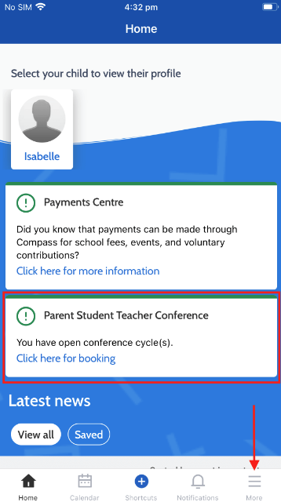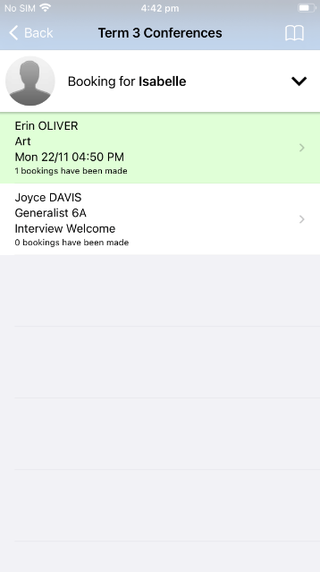

**Mildura Primary School**

**Booking Student Learning Conferences in the Browser**

1. Graphical user interface, application

   Description automatically generatedLog on to Compass

https://milduraps-vic.compass.education

1. Select Community > Conferences

1. Select Student Learning Conference > My Bookings

1. Choose a teacher from the right and then choose a timeslot.

